**Overview**

**Topic:**An overview of what you propose to do in your project. Concentrate on the big picture and outcomes, rather than intricate details. At least two paragraphs are expected.

As thoroughly examined and explained within the Project Idea part of Assignment 2, the main idea of our project is application that helps parents/guardians to manage and plan routines and task to organize their children. The app will be named ‘Advenchore Quest’ and contains a game that will be used in conjunction with sets of routines and tasks, so children will be motivated to complete the responsibilities that parents and guardians have prepared. This program will be used by both parents and children, to help them get through the day. The big picture like many other applications, is to make life easier for a certain demographic. Allowing time to relax and take some time off on a hectic day is important, and will allow for better decision making and positive mental wellbeing as the day goes on.

The main outcome that can be achieved by creating this program is more time for parents/guardians and, organizational skills development within kids at a younger age. Having more time will allow for a better and less stressful day for parents, whereas kids will learn the fundamental factors of what organization is and how to commit to a plan at a young age. This application will benefit both parties in different ways, allowing them to grow as smarter and better people. We are not expecting these outcomes to be evident the moment the program is developed, but rather through actual use of the program over a period of time. Until the users of the program are comfortable with every feature and somewhat develop a sense of dependency with a planner application. Only then can evidence of a positive outcome be perceived. Through this phase of seeing the positive impacts, we will also be able to see the negative aspects. This will enable us to get an understanding of what was wrong with the first iteration and address these problems before an updated version in complete. This cycle will be continuous, throughout the lifetime of the application.



**Motivation:**

What are your motivations for your project? Why is this project important or interesting? How does it fit in with current IT trends? What would it show to a future employer if you were able to work on this project? At least one paragraph is expected.

One of the main motivations behind the creation of the project is the wide demographic which is plagued by the same problem. By concentrating efforts on a group of people who share the same dilemma, it will allow us to offer a digital solution as well as kickstart innovation within a market where customers have a lack of option or input. Giving the user what they want is one other motivation behind the idea of the application. There are many planners out there who claim to be the best, but to truly be the best they must offer all the features that customers want and then some more. This project is important as it is designed to actually help people instead of waste their time. Offering users with a refreshing and innovative program, instead of one that’s full of gimmicks which they might use for a couple of days and then delete. Ensuring that they find some level of dependability with the application to run a fraction of their day and make everyone’s life a bit easier.

This idea was conceived at the perfect time and place that it’s a mystery why there isn’t something out there like this now. With new digital trends affecting everyone’s life nowadays, its hard to see any good innovations that actually creates a positive impact on peoples lives. It’s now been a decade since people have been dependent of application to run parts of their life. For example, instead of going to the bank to manage your bank account, most people use the application on their phones to view and change items. This can be said about virtually anything that we interact with including, food, friends, entertainment and even work. There are millions of applications that people depend on to get through their day, and that number is only rising. As people have grown custom to using application on a daily basis, there are many looking for more useful application that fit into their lives. With parents and guardians who have grown up with the boom of technology, social media, and useful applications they will be ecstatic to find an application that offers what our project Idea encompasses.

By continuing efforts on creating a working prototype and even a finished product down the line, will show future employers that we see the world changing around us, and understand what people what. This we believe is valued by employers, as finding what people want and need without them knowing is the basic backbone of big-name companies that are household names in this day and age. Through this employer will also understand that we have the brains to think of an innovation and the guts to go through with it till the end. This will let them know that we are genuinely interested and motivated on innovative ideas. There are many stories of people who have through of a spectacular idea but did not have the motivation or bravery to go though with it or even try. Employers will also become aware of the skill that the individuals within our group possess, as making an application from scratch is no easy task but takes months of planning and hard work. Through that hard work they will see that we are all determined and have a sense of responsibility to deliver quality work.

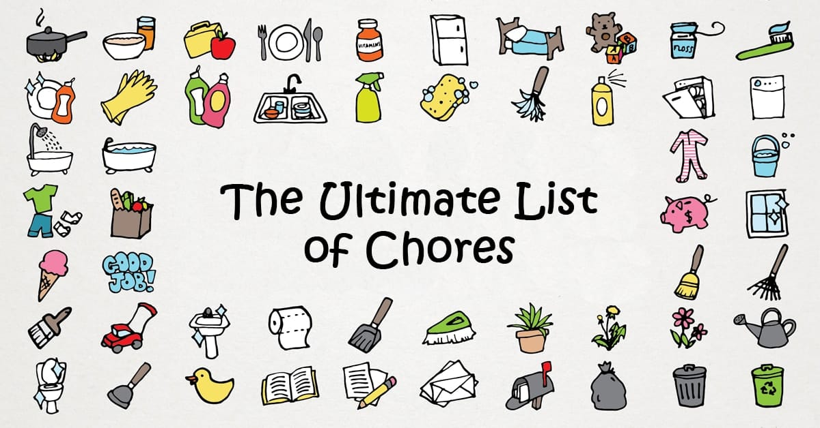

**Landscape**:

What similar systems or products are available? What competitors are there? What points of difference are there about your project compared to what exist now? At least one paragraph is expected.

There are a number of other applications that offer a similar feature set to our project idea. These include:

* The Cozie Chore App
* S’moresUp Chores
* Our Home Chores
* Kachinga Chore and Allowance
* Greenlight Chore and Allowance

These market leading applications lack a factor that we believe is vital to establish motivation amongst children. Our innovative feature is a built-in game that is connected with the tasks and chores that children do. Enabling children to feel a sense of accomplishment after completing a task or chore assigned by a guardian or parent. Most of these applications were explained within Project Ideas within Assignment 2. These application focus on one aspect such as being a planner or allowance manager which are the main features that are littered within all parenting application. There is no application that allows the child to feel properly involved and motivated to organize and get into the mind set of getting things done.

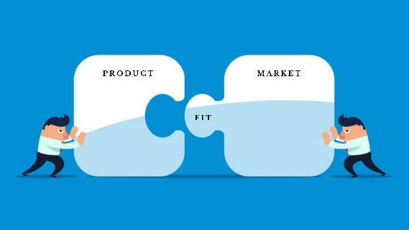With this idea in mind, introducing a game is game changing as it keeps the child engaged by means of completing tasks and chores, helping them to stay organized will having fun along the way. Other applications focus more on parental control and how parents have full control over the application. Our idea takes that into consideration as parents/guardians, are defiantly in control of their own children and decide how they do their chores and play the game. Other applications also look towards a straighter forward way that makes doing tasks and chores repetitive and somewhat boring, which does not engage children and instead builds a negative association to doing work. We’re keeping children motivated and intrigued with a game and unique feature will positively change the way they think about doing work. The best way to get this application to our demographic we think is through clever marketing strategies like, smart advertising and thorough investigation into our competitors and how they are presenting their product. Smart advertising techniques such as, pin pointing digital platforms which our main target audience use and advertising our product there. Through review we have seen our intended demographic ages varying from late 20’s to mid-30’s using social media, and other social interactive software’s. Paying money to these companies and becoming licensed advertisers, will defiantly promote our product to the right people at the right time in their live. Having an understating of our competitors and how they operate is important as well. Using their products, services and even having discussions with their developers will help us understand how they reach their particular set of users. Understanding how similar application on different markets work will also give us ample data to review and use in future efforts. As we go on, we will defiantly find more ways to integrate our product into people’s lives, such as building brand loyalty with users and using word of mouth to further spread the product.

**References:**

Haije, E. and Haije, E., 2021. *Top 20 Mobile Development Tools: An Overview - Mopinion*. [online] Mopinion. Available at: <https://mopinion.com/mobile-development-tools-an-overview/> [Accessed 19 January 2021].

Momentumlife.co.nz. 2021. *7 Important reasons why kids should have chores*. [online] Available at: <https://www.momentumlife.co.nz/stories/why-kids-should-have-chores> [Accessed 13 February 2021].

Deloittedigital.com. 2021. *How technology is changing the world during COVID-19*. [online] Available at: <https://www.deloittedigital.com/us/en/blog-list/2020/how-technology-is-changing-the-world-during-covid-19.html> [Accessed 12 February 2021].

Pocket-lint. 2021. *Life in the future: Tech that will change the way we live*. [online] Available at: <https://www.pocket-lint.com/gadgets/news/142027-tech-innovations-that-will-shortly-change-the-world> [Accessed 12 February 2021].

AgingInPlace.org. 2021. *Technology in Our Life Today and How It Has Changed | Updated for 2020 | AgingInPlace.org*. [online] Available at: <https://aginginplace.org/technology-in-our-life-today-and-how-it-has-changed/#:~:text=Over%20the%20years%2C%20technology%20has,useful%20information%20at%20our%20fingertips.&text=With%20all%20of%20these%20revolutions,%2C%20better%2C%20and%20more%20fun.> [Accessed 12 February 2021].

Verywell Family. 2021. *Why You Should Be Giving Your Kids More Chores*. [online] Available at: <https://www.verywellfamily.com/the-importance-of-chores-for-kids-1095018> [Accessed 13 February 2021].

OpenLearn. 2021. *Information Technology: A New Era?*. [online] Available at: <https://www.open.edu/openlearn/people-politics-law/politics-policy-people/sociology/information-technology-new-era/content-section-1> [Accessed 19 January 2021].